Design and analysis of wagon wheel and track
Abstract:
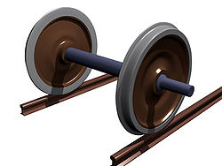
A train wheel or rail wheel is a type of wheel specially designed for use on rail tracks. A rolling component is typically pressed onto an axle and mounted directly on a locomotive or indirectly on a bogie, also called a track. Wheels are cast or forged (wrought) and are heat treated to have a specific hardness. A railroad wheel typically consists of two main parts: the wheel itself, and the tire (or tyre) around the outside. A rail tire is usually made from steel, and is typically heated and pressed onto the wheel,
While by damping, compression forces and stress rail wheel under goes crakes and spalling in the wheel threads wheels increase rolling resistance, reduce energy efficiency and may create unsafe operation. Which cause more damages.
In this project we design the wagon wheel and track and perform structural analysis in solid works premium2014.

